ASSIGNMENT # 06

**Air**

**Conditioning**

**Cycle**

**EXPERIMENT # 5:**

**DEMONSTRATION OF THE WORKING OF**

**AIR CONDITIONER CYCLE**

**Introduction :**

“Air conditioning  is the process of removing heat and moisture from the interior of an occupied space to improve the comfort of occupants.”

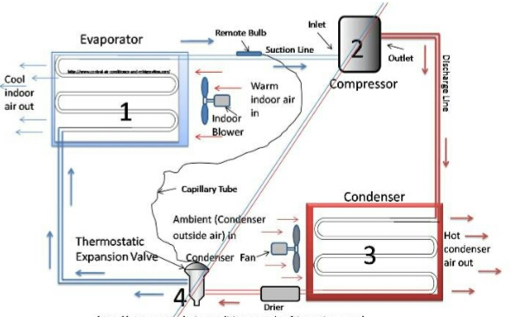 **Figure # 6-1:( air-conditioning cycle)**

**Parts Lists:**

An air conditioning system consists of five mechanical components:

* Compressor
* Fan
* Condenser Coil (Hot)
* Evaporator Coil (Cool)
* Chemical Refrigerant

**WORKING:**

**Refrigerant:**

* Refrigerant moves through an air conditioners cooling tubes and copper coils, connecting the inside unit to the outside unit. It absorbs heat from your indoor air, changing states from gas to liquid. After absorbing heat from the inside air, the refrigerant travels to the outdoor unit where the heat is pushed outdoors.

**Compressor:**

* The job of the compressor is to pressurize the refrigerant, thus raising its temperature. Due to the combined gas law (a combination of Boyle’s Law, Charles’ Law, and Gay-Lussac’s Law), which states that if pressure increases so does its temperature, when you compress the refrigerant, it will heat up. It does this by squeezing the gas very tightly together.
* We heat up the refrigerant in order to get its temperature higher than the outdoor temperature. Since heat naturally flows from a hotter to colder bodies, in order to dispense heat outdoors, the refrigerant must be hotter than the air outdoors. This is why we need the compressor to increase its pressure and thus its temperature.

**Condenser:**

* The condenser coil is in the outdoor air conditioning unit. It receives the high pressure, high temperature refrigerant from the compressor. You can think of it as the opposite of the evaporator coil. Whereas the evaporator coils contain cold refrigerant, the condenser coils contain hot refrigerant.
* The condenser coils are designed to facilitate heat transfer to the outdoor air. The refrigerant releases heat energy with the aid of the condenser fan, which blows air over the coils. As the heat leaves the refrigerant to the outside environment, it turns back into a liquid where it then flows to the expansion valve, which depressurizes the refrigerant and cools it down.

**Expansion Valve:**

* When the refrigerant leaves the condenser in its liquid state, it has dispersed heat, but it is still too hot to enter the evaporator coils. Before the refrigerant passes to the evaporator coils, it must be cooled down. This is where the expansion valve (also known as a metering device) comes in, normally a thermostatic expansion valve.
* Again using the principles behind the combined gas law, which states that when pressure decreases so does its temperature, the expansion valve depressurizes the refrigerant and cools it down?
* An expansion valve removes pressure from liquid refrigerant allowing for the refrigerant to change from a liquid to a vapor/gas in the evaporator. It also controls the amount of refrigerant/voltage flow entering the evaporator.

**Evaporator Coil:**

* Evaporator coils are very important to an air conditioner. It’s where the air conditioner actually picks up the heat from inside your home.
* The copper tubes receive the depressurized, liquid refrigerant from the expansion valve. When your indoor air blows over the cold coils, the heat from inside the home gets absorbed. This is because of the 2nd law of thermodynamics which states that heat flows naturally from hot to cold. Just like the condenser coils need the help of the condenser fan to facilitate heat transfer, the evaporator coils rely on the indoor air handler’s fan (aka the blower) to blow air over the coils.
* As the refrigerant absorbs heat from the indoor air, it starts to evaporate to form a vapor.

**Heat Exchanger:**

“It is a device which transfer heat from system to surrounding and vice versa.”

* Condenser
* Evaporator
* Actually, it depends on inlet.

**APPLICATIONS:**

* Commercial buildings, which are built for commerce, including offices, malls, shopping centers, restaurants etc.
* High-rise residential buildings, such as tall dormitories and apartment blocks.
* Industrial spaces where thermal comfort of workers is desired.
* Cars, aircraft, boats, which transport passenger or fresh goods.
* Institutional buildings, which includes government buildings, hospitals, schools etc.
* Low-rise residential buildings, including single-family houses, duplexes, and small apartment buildings.

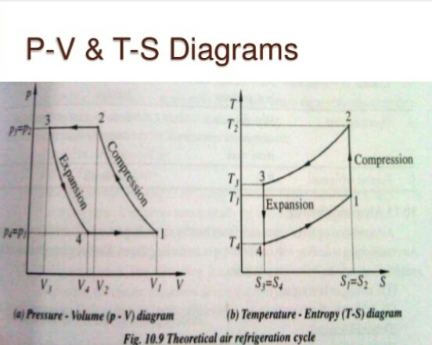**Graphical Representation:**

***“Thank you teacher for helping me BLOOM”***